***Manipulating Attributes with jQuery***

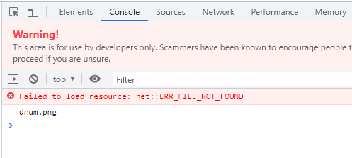

***Code:***

**Index3.html:**

<!DOCTYPE html>

<html lang="en" dir="ltr">

<head>

<meta charset="utf-8">

<title>jQuery</title>

<link rel="stylesheet" href="styles3.css">

</head>

<body>

<h1 class="big-title margin-50">Hello.</h1>

<img src="drum.png" alt="">

<a href="http://www.google.com">Search</a>

<!--We want to add a and img attributes using js and jQuery-->

<button>Click Me</button>

<button>Click Me</button>

<button>Click Me</button>

<button>Click Me</button>

<button>Click Me</button>

<script src="https://ajax.googleapis.com/ajax/libs/jquery/3.6.0/jquery.min.js"></script> <!--Paste it above below tag-->

<script src="index3.js" charset="utf-8"></script>

</body>

</html>

**Index3.js:**

//We want to add a and img attributes using js and jQuery

//$("img").attr("src"); //$<class>.attr<name of attribute>; attr means attribute and src means source

//console.log($("img").attr("src"));

//console.log($("a").attr("href"));

//Let's change attribute

$("a").attr("href","http://www.yahoo.com"); //<class>.attr<name of attribute, new attribute>;

//console.log($("a").attr("href","http://www.yahoo.com"));

console.log($("h1").attr("class"));

**Styles3.css:**

.big-title{

font-size: 10rem;

font-family: cursive;

color: yellow;

}

.margin-50{

margin: 50px;

}